Basic Linux Command

1) whoami : This command prints the username associated with the current effective user ID.

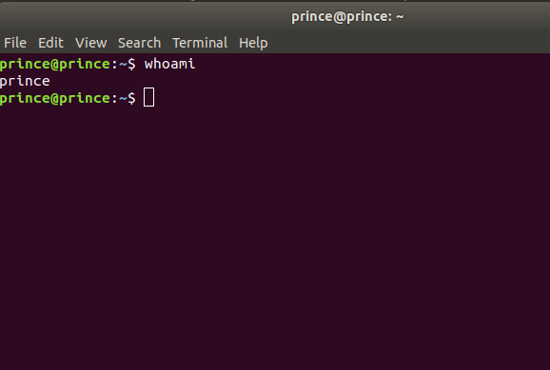

2) hostname : The hostname command shows or sets the system hostname.
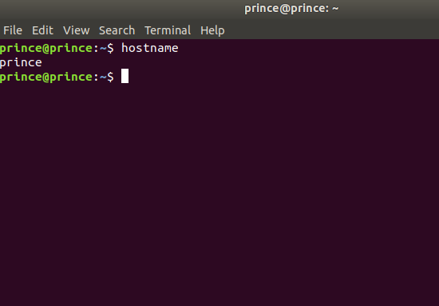

3) pwd: hort for print working directory, pwd is a Linux, Unix, and FTP command to print the directory you're currently working in when at the command line.
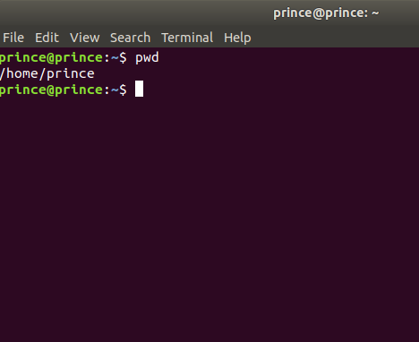

4) ls : ls lists the files in the current working folder.
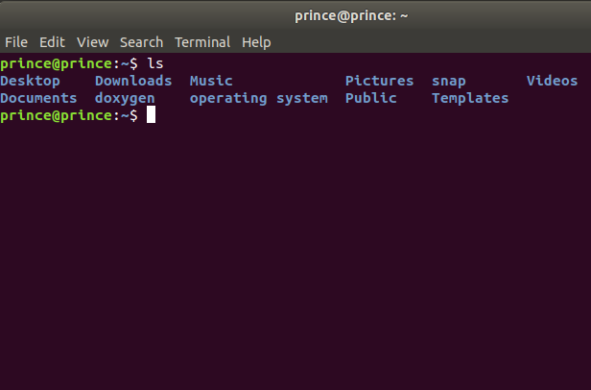

5) ls -a: list all files including hidden file starting with '.'

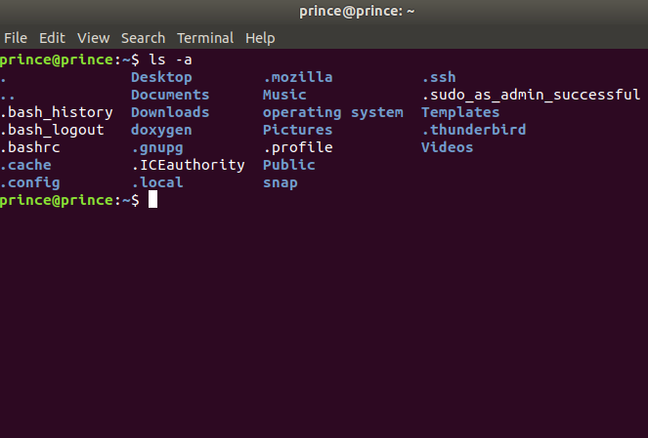
6) cd: The cd command, which stands for "change directory", changes the shell’s current working directory .

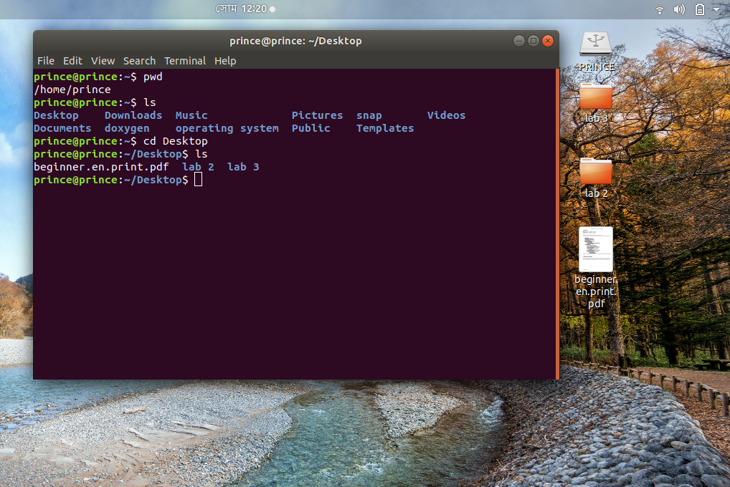

7) mkdir: The mkdir command creates new directories in your file system.
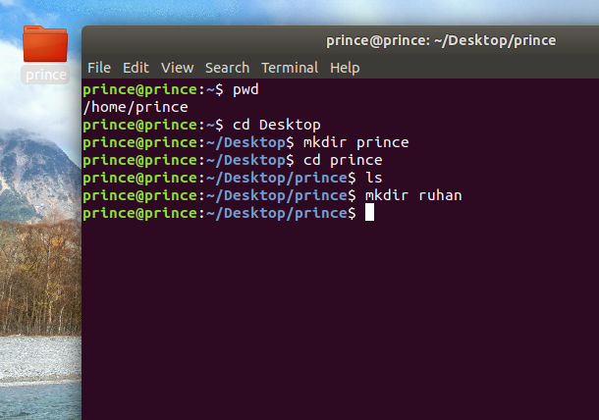
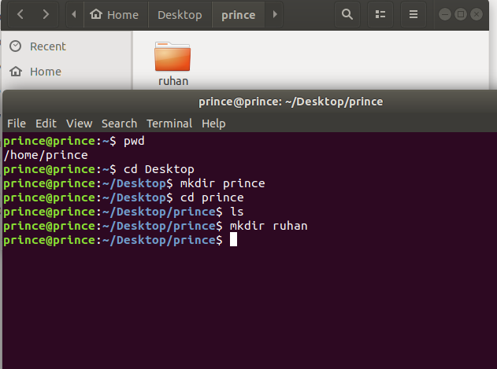

8) cd .. : Move one directories up.

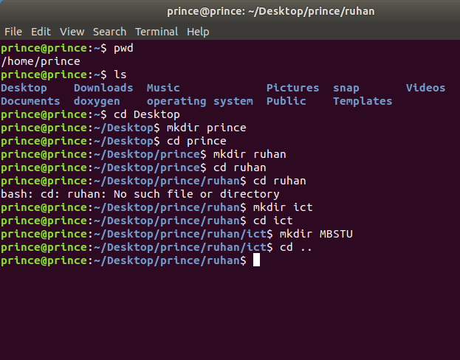

9) cd .. .. : Move two directories up.

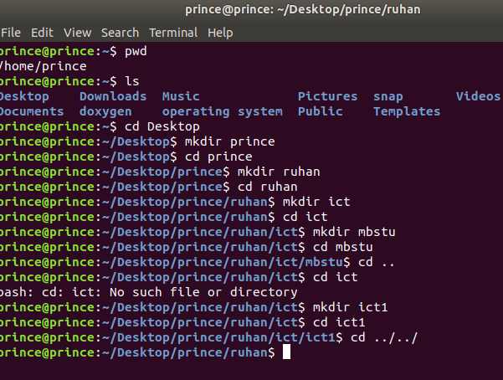

10) rmdir: remove a directory.
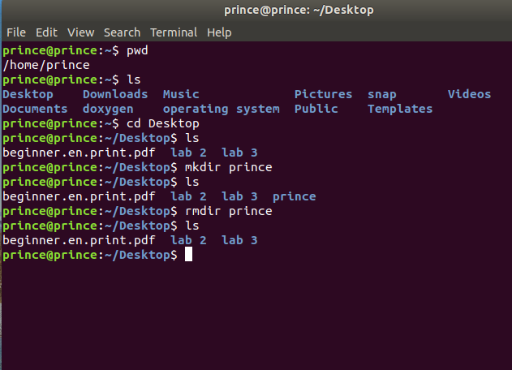
11) rm -r: remove directory with its content.
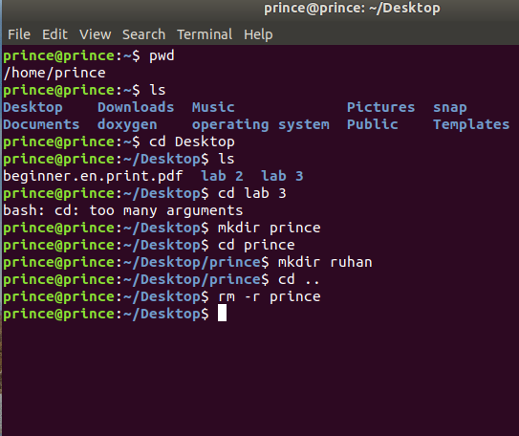

12) gedit : Working with text editors: $ gedit ---> its an editor

